OLD CONWAY RODERICK de CAZALET KNIGHT (26-27)

Date & Place Of Birth
26th August 1911 in the small village of Elkhorne, Manitoba, Canada

Previous School
Monkton Coombe School, Nr Bath, Somerset, UK (just three miles for your researcher!)

Conway Dates
Joined January 1926
Left December 1927 to “join his family at 3743 Blenheim St., Vancouver, BC.

Cadet Number 117

Next of Kin Listed
Mr J D K & Mrs R E Knight in Canada.
Uncle Mr D H Knight of Surbiton, Surrey, later Bruges.
Then Aunt Miss Knight of Wimbledon so perhaps the family originated from London.

Performance
Naval Reports: His conduct was always Good and in his last term he was second in his class.
Academic Reports: His conduct was always Good and he was rated 5th or 6th in his class in each of his six terms.

Achievements
He was not in any of the sports teams (cricket, sailing, swimming, boxing or rugby) but he was one of 12 competitors for the Liverpool Shipwreck & Humane Society’s swimming medal. He was not placed but was commended by the examiner for his very high standard.
He was not made a cadet captain i.e. a prefect in charge of other cadets.
In his last term he was runner up for the Seamanship Prize and appears to have been presented with a pair of binoculars.
He was confirmed by the Lord Bishop of Warrington on Tuesday 31st June 1927.
Passing Out Certificate: He received an Extra Certificate from his passing out exams which very few managed, his conduct was rated Very Good and his ability Above Average.

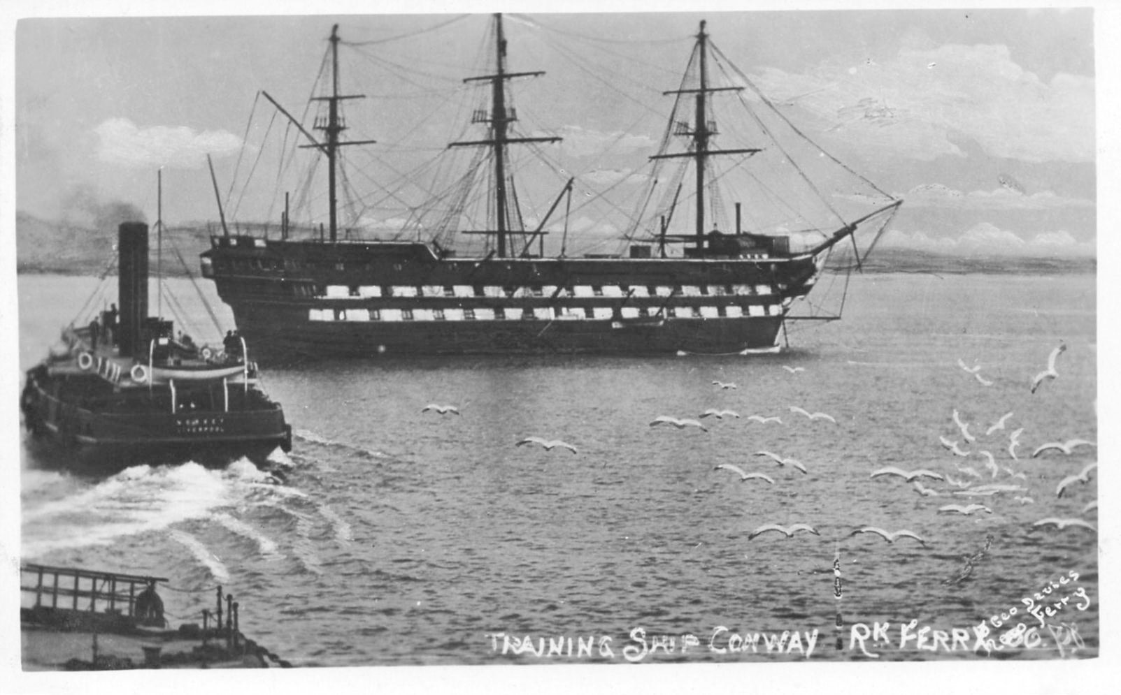
Above: Conway in 1925 moored off Rock Ferry Pier in that part of the River Mersey known as The Sloyne. Rock Ferry pier and ferry in foreground.

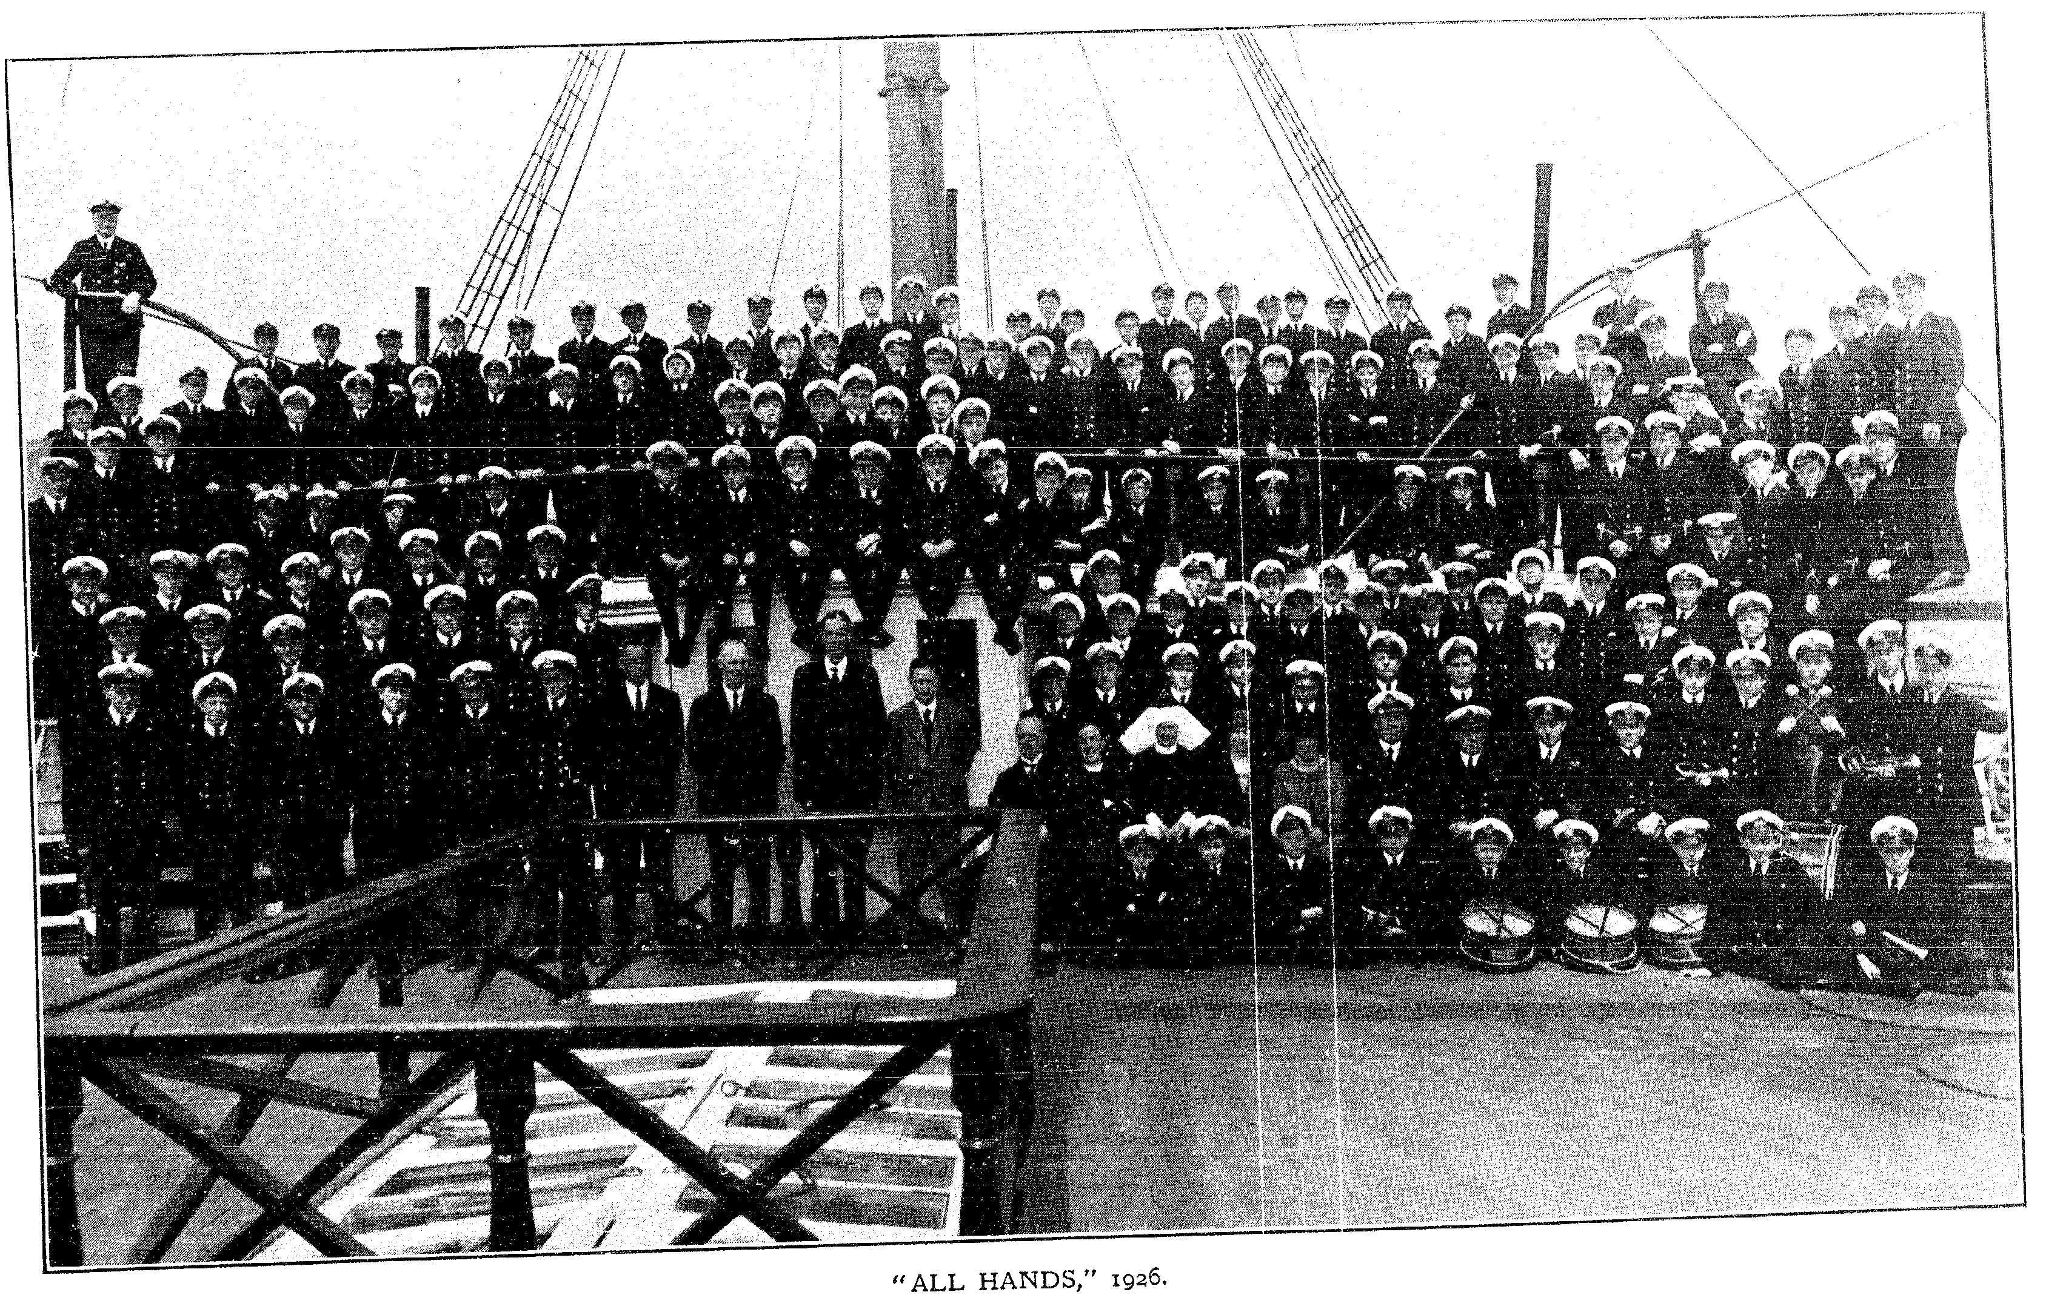
Above: Ship’s Company 1926 – he’s in there somewhere!

